|  |
| --- |
| DOKUZ EYLUL UNIVERSITY fACULTY OF ENGINEERING DEPARTMENT OF COMPUTER ENGINEERING |
| CME 3204 - Data Communications and Computer Networks |
| **Project - Milestone 1** |
|  |
| **2015510013 – GUL EDA AYDEMİR 2014510027 - HANDE NUR ENER 2400000127 -BAHADIR ŞAMLI** |
|  |
| **4/25/2018** |

TABLE OF CONTENTS

1. Introduction #
   1. **Project Definition and Problem Formulation**

## The purpose and motivation of the project

## Term Definitions

## Related Work

1. Methods and Tools #

## Simulation and Modeling Concepts

## Simulation Environment/Tool

1. Network Design Requirements #
2. **Requirement Analysis**
3. **Deﬁnitions of the System/Model**
4. **Simulation Elements**

1. References #
2. References
3. Introduction
   1. **Project Definition and Problem Formulation**

## In the project we need to create an internet infrastructure for a university that has the most appropriate metropolitan area network to fulfill the specified functions by using the necessary components. It should be appropriate to the actual network structure used today. Some of the problems that we can encounter and solve are how to choose the appropriate topology, how to make the most efficient use of the necessary components at a minimum, and how the systems communicate with each other quickly, cheaply and without interruption.

## The purpose and motivation of the project

## Which motivations are there behind of this project? Creating a project will enable us to learn how a metropolitan area network works. The biggest motivation is to be able to learn how the background of the internet that we use every day, what structures are used and what the Internet provides us with.

## What is the purpose and business goals of the project? The project aims to learn directly what the internet components of a network structure are and how they relate to each other. We are expected to create the most suitable network structure in the project. At the same time, we have information about the internet infrastructure and it is possible to work in this field in the future. The structure created for those who are considering to work in this area in the future will be an idea about projects that will implement real life.

## Why do you want to realize this project? It is a great advantage for us to have an idea of this area by learning about the events that take place in the background of the Internet. By knowing in detail what our Internet speed depends on, we are able to consciously benefit from it. As an advanced level, we are not cautious about security vulnerabilities that may occur in our communications on the internet. If we think about working in this area, we can improve ourselves and give us the chance to recognize the mistakes and deficiencies in existing systems. At the same time, this project will look nice on our CVs. For these reasons we want to realize this project.

## What are the main benefits and risks? Many of the features mentioned above actually describe the contribution of the project to us. To sum up, it teaches us what the Internet is really about, its components in the background and how to use them. It also provides a preliminary study of the structures we can apply in real life. We can not say for certain whether there is any risk.

## Term Definitions

## Node

## In a communications network, a network node is a connection point that can receive, create, store or send data along distributed network routes. Each network node -- whether it's an endpoint for data transmissions or a redistribution point -- has either a programmed or engineered capability to recognize, process and forward transmissions to other network nodes.[1]

## Packet

## A packet is the unit of data that is routed between an origin and a destination on the Internet or any other packet-switched network. [4]

## Channel

## A communication channel or simply channel refers either to a physical transmission medium such as a wire, or to a logical connection over a multiplexed medium such as a radio channel in telecommunications and computer networking.[20]

## Protocol

## In information technology, a protocol is the special set of rules that end points in a telecommunication connection use when they communicate. The TCP/IP Internet protocols, a common example [21]

## System

## A system is a collection of elements or components that are organized for a common purpose. A computer system consists of hardware components that have been carefully chosen so that they work well together and software components or programs that run in the computer.[22]

## Architecture

## Network architecture is the design of a communication network. It is a framework for the specification of a network's physical components and their functional organization and configuration, its operational principles and procedures, as well as data formats use.[23]

## Router

## In packet-switched networks such as the internet, a router is a device or, in some cases, software on a computer, that determines the best way for a packet to be forwarded to its destination.[24]

## Switch

## A network switch (also called switching hub, bridging hub, officially MAC bridge[[1]](http://www.wiki-zero.com/index.php?q=aHR0cHM6Ly9lbi53aWtpcGVkaWEub3JnL3dpa2kvTmV0d29ya19zd2l0Y2gjY2l0ZV9ub3RlLTE)) is a [computer networking device](http://www.wiki-zero.com/index.php?q=aHR0cHM6Ly9lbi53aWtpcGVkaWEub3JnL3dpa2kvQ29tcHV0ZXJfbmV0d29ya2luZ19kZXZpY2U) that connects devices together on a [computer network](http://www.wiki-zero.com/index.php?q=aHR0cHM6Ly9lbi53aWtpcGVkaWEub3JnL3dpa2kvQ29tcHV0ZXJfbmV0d29yaw) by using [packet switching](http://www.wiki-zero.com/index.php?q=aHR0cHM6Ly9lbi53aWtpcGVkaWEub3JnL3dpa2kvUGFja2V0X3N3aXRjaGluZw) to receive, process, and forward data to the destination device.[25]

## Network

## A computer network is a group of computer systems and other computing hardware devices that are linked together through communication channels to facilitate communication and resource-sharing among a wide range of users.[26]

## Hub

## A hub refers to a hardware device that enables multiple devices or connections to be connected to a computer.[27]

## Host

## A network host is a [computer](http://www.wiki-zero.com/index.php?q=aHR0cHM6Ly9lbi53aWtpcGVkaWEub3JnL3dpa2kvQ29tcHV0ZXI) or other device connected to a [computer network](http://www.wiki-zero.com/index.php?q=aHR0cHM6Ly9lbi53aWtpcGVkaWEub3JnL3dpa2kvQ29tcHV0ZXJfbmV0d29yaw). A network host may offer information resources, services, and applications to users or other [nodes](http://www.wiki-zero.com/index.php?q=aHR0cHM6Ly9lbi53aWtpcGVkaWEub3JnL3dpa2kvTm9kZV8obmV0d29ya2luZyk" \o "Node (networking))on the network. A network host is a network node that is assigned a [network address](http://www.wiki-zero.com/index.php?q=aHR0cHM6Ly9lbi53aWtpcGVkaWEub3JnL3dpa2kvTmV0d29ya19hZGRyZXNz).[28]

## Bandwidth

## Bandwidth is the capacity of a wired or wireless network communications link to transmit the maximum amount of data from one point to another over a computer network or internet connection in a given amount of time -- usually one second. Synonymous with capacity, bandwidth describes the [data transfer rate](https://searchunifiedcommunications.techtarget.com/definition/data-transfer-rate). Bandwidth is not a measure of network speed -- a common misconception.[29]

## Related Work

## In this project, the team has been required to design and implement the proposal for the Dokuz Eylul University. There is a study by Soham Ghosh that Network Design Proposal for University by Packet Tracer shown in the reference[30]. Also, there is an another study that made by Mohammed Nadir Bin Ali and friends, called Design and Implementation of a Secure Campus Network [31]. In this study, one section has mentioned about Cost Effective Secure Campus Network Design which is related with the main project.

1. Methods and Tools

## Simulation and Modeling Concepts

Discrete event simulation utilizes a mathematical/logical model of a physical system that portrays state changes at precise points in simulated time. Both the nature of the state change and the time at which the change occurs mandate precise description. Customers waiting for service, the management of parts inventory or military combat are typical domains of discrete event simulation." [35]

A more theoretical top-down description of discrete-event simulations is the following: The start of a discrete- event simulation is a model. A model is the construction of a conceptual framework, used to represent a system. The specific characteristics of discrete-event simulation model are the following:

1. Stochastic: At least some of the models components are stochastic. This means that there is a certain factor of randomness in the model. This is represented by random number generators, which are explained in the terminology.
2. Dynamic: The time evolution of the system’s components is important. Time is a significant variable.
3. Discrete: The state of the system changes only significantly when events occur at discrete time instances.

The difference with [continuous simulations](http://en.wikipedia.org/wiki/Continuous_simulation) is the use of the factor time. The system evolves over time so the variables change continuously in a continuous simulation. Whereas in a discrete event simulation the events itself determine if something happens or not. Time can go by without anything happening.

A combination of discrete and dynamic simulation is called a combined simulation. The basic is a continuous simulation but certain discrete events interfere the continuity of the simulation making it a combined simulation.

## The benefits of the simulation programs over to the real implementations are ;

## The team test our system before using it

## The team see errors of the structure before implementing it

## The team also have chance to improve used systems

## Simulation Environment/Tool

## Advantages-disadvantages and concepts/approaches of simulation tool you chose?

## CISCO pocket tracer is actually a software relating to network. Advantage: 1)it is easy to use and can be used on the any place you want. 2) One of the best advantage of it is the Sim mode which otherwise don’t available in the real gear thing. 3) It enables it’s users to simulate the configuration relating to the  Cisco routers. Disadvantage: 1)it may cause the loops by affecting the STP. 2) It don’t  support the  ether channel regarding the access layer switches. 3) With regard to the Frame relay it is low in command.

* **Which reasons lead you to choose the simulation tool you chose?**

This environment contains abstractions from the real world, abstractions for host machines, routers, wireless connections, fibre cables, user patterns and so on. Network simulators are typically used by researchers, engineers and developers to design various kinds of networks, simulate and then analyse various parameters on the network performance. In network education, there is need for practical hands-on skills alongside the theory that students learn through a course. However, a dedicated network laboratory is expensive and is both difficult and expensive to maintain. A better alternative is to use a network simulator to give the students some kind of practical experience working with networks. Some network simulators, like ns-2, are designed for research and may be too complex and difficult to use for educational purposes. Other network simulators are designed in a way that makes them more suitable for education. One example of such a simulator is Packet Tracer, which is an integral part of the Cisco Network Academy Program. Network simulators used in commercial development is outside the scope of this thesis; however the benefits of using network simulators in research should also apply to development of commercial software.

* **Information about the tool**
* **Overview**

Packet Tracer is a [c](https://wiki2.org/en/Cross-platform)ross platformvisual simulationtool designed by Cisco Systemsthat allows users to create network topologiesand imitate modern computer network. The software allows users to simulate the configuration of Cisco routers and switches using a simulated command line interface. Packet Tracer makes use of a drag and dropuser interface, allowing users to add and remove simulated network devices as they see fit. The software is mainly focused towards Certified Cisco Network Associate Academy students as an educational tool for helping them learn fundamental CCNA concepts.

In addition to simulating certain aspects of computer networks, Packet Tracer can also be used for collaboration. As of Packet Tracer 5.0, Packet Tracer supports a multi-user system that enables multiple users to connect multiple topologies together over a computer network.Packet Tracer also allows instructors to create activities that students have to complete. Packet Tracer is often used in educational settings as a learning aid.Cisco Systems claims that Packet Tracer is useful for network experimentation.

* **How to program or run simulation?**

Packet Tracer is a protocol simulator developed at Cisco Systems. Packet Tracer (PT) is a powerful and dynamic tool that displays the various protocols used in networking, in either Real Time or Simulation mode. This includes layer 2 protocols such as Ethernet and PPP, layer 3 protocols such as IP, ICMP, and ARP, and layer 4 protocols such as TCP and UDP. Routing protocols can also be traced. Packet Tracer is a supplement to and not a replacement for experience with real equipment. Students are encouraged to compare the results obtained from Packet Tracer network models with the behavior of real equipment.  **Creating a New Topology in Packet Tracer**Start Packet Tracer [**[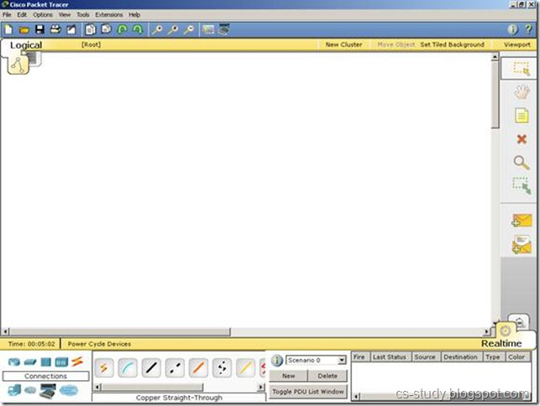](http://lh6.ggpht.com/-82YtSehddNo/UI2PXDwYt1I/AAAAAAAAAqY/aw_A6T6sjZY/s1600-h/clip_image002%25255B12%25255D.jpg)**](http://lh6.ggpht.com/-82YtSehddNo/UI2PXDwYt1I/AAAAAAAAAqY/aw_A6T6sjZY/s1600-h/clip_image002%25255B12%25255D.jpg) **Choosing Devices and Connections**We will begin building our network topology by selecting devices and the media in which to connect them. Several types of devices and network connections can be used. For this lab we will keep it simple by using End Devices, Switches, Hubs, and Connections. Single click on each group of devices and connections to display the various choices. When we select a device in the left panel, in the right panel we see all the listed devices of that type. Single click on the End Devices. **[[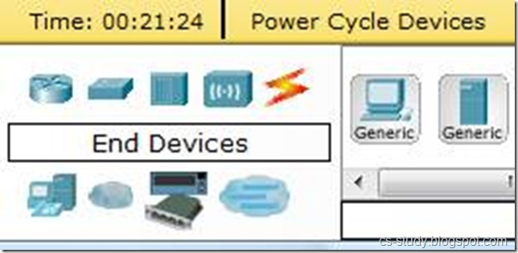](http://lh3.ggpht.com/-vSgdtst2ajU/UI2PgdpoJUI/AAAAAAAAArM/gUCrg0wMFpE/s1600-h/clip_image017%25255B1%25255D%25255B4%25255D.jpg)](http://lh3.ggpht.com/-vSgdtst2ajU/UI2PgdpoJUI/AAAAAAAAArM/gUCrg0wMFpE/s1600-h/clip_image017%25255B1%25255D%25255B4%25255D.jpg" \t "_blank)**Single click on the Generic host. [**[](http://lh3.ggpht.com/-4FMzwIPgu7o/UI2Pin_zItI/AAAAAAAAArc/g_Ltdxf49UM/s1600-h/clip_image017%25255B2%25255D%25255B4%25255D.jpg)**](http://lh3.ggpht.com/-4FMzwIPgu7o/UI2Pin_zItI/AAAAAAAAArc/g_Ltdxf49UM/s1600-h/clip_image017%25255B2%25255D%25255B4%25255D.jpg)Move the cursor into topology area. You will notice it turns into a plus “+” sign. [**[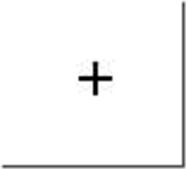](http://lh3.ggpht.com/-Zrw5Kh8zNjw/UI2PlJ1VDnI/AAAAAAAAArs/iIPbT5xh3Qk/s1600-h/clip_image026%25255B5%25255D.jpg)**](http://lh3.ggpht.com/-Zrw5Kh8zNjw/UI2PlJ1VDnI/AAAAAAAAArs/iIPbT5xh3Qk/s1600-h/clip_image026%25255B5%25255D.jpg)Single click in the topology area and it copies the device.Add three more hosts.  **Adding a Hub**Select a hub, by clicking once on Hubs and once on a Generic hub.Add the hub by moving the plus sign “+” below PC0 and PC1 and click once. Connect PC0 to Hub0 by first choosing Connections. Click once on the Copper Straight-through cable. Perform the following steps to connect PC0 to Hub0:

1. Click once on PC0
2. Choose FastEthernet
3. Drag the cursor to Hub0
4. Click once on Hub0 and choose Port 0
5. Notice the green link lights on both the PC0 Ethernet NIC and the Hub0 Port 0 showing that the link is active.

Repeat the steps above for PC1 connecting it to Port 1 on Hub0. (The actual hub port you choose does not matter.   
[[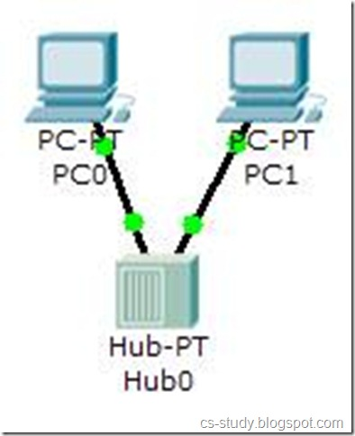](http://lh4.ggpht.com/-7RAlZdzFTV8/UI2QVr2YRUI/AAAAAAAAAvs/gbyao_RmHtQ/s1600-h/clip_image055%25255B5%25255D.jpg)](http://lh4.ggpht.com/-7RAlZdzFTV8/UI2QVr2YRUI/AAAAAAAAAvs/gbyao_RmHtQ/s1600-h/clip_image055%25255B5%25255D.jpg)  
 **Adding a Switch**   
Select a switch, by clicking once on Switches and once on a 2950-24 switch.  
Add the switch by moving the plus sign “+” below PC2 and PC3 and click once.  
Connect PC2 to Hub0 by first choosing Connections.   
Click once on the Copper Straight-through cable   
  
[[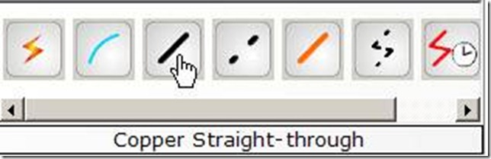](http://lh3.ggpht.com/-R53dob_H-3g/UI2Qn3p2z_I/AAAAAAAAAxc/W2wWxhQpDQE/s1600-h/clip_image043%25255B1%25255D%25255B3%25255D.jpg)](http://lh3.ggpht.com/-R53dob_H-3g/UI2Qn3p2z_I/AAAAAAAAAxc/W2wWxhQpDQE/s1600-h/clip_image043%25255B1%25255D%25255B3%25255D.jpg)  
  
Perform the following steps to connect PC2 to Switch0:

1. Click once on PC2
2. Choose FastEthernet
3. Drag the cursor to Switch0
4. Click once on Switch0 and choose FastEthernet0/1
5. Notice the green link lights on PC2 Ethernet NIC and amber light Switch0 FastEthernet0/1 port. The switch port is temporarily not forwarding frames, while it goes through the stages for the Spanning Tree Protocol (STP) process.
6. After a about 30 seconds the amber light will change to green indicating that the port has entered the forwarding stage. Frames can now forwarded out the switch port.

Repeat the steps above for PC3 connecting it to Port 3 on Switch0 on port FastEtherent0/2. (The actual switch port you choose does not matter.)   
[[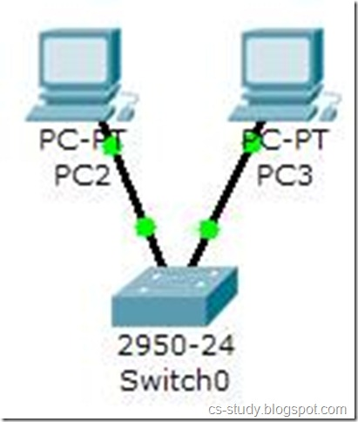](http://lh6.ggpht.com/-89KFryt1pHE/UI2Q7tuCjoI/AAAAAAAAAzM/NRxhN_UJ6Fw/s1600-h/clip_image078%25255B5%25255D.jpg)](http://lh6.ggpht.com/-89KFryt1pHE/UI2Q7tuCjoI/AAAAAAAAAzM/NRxhN_UJ6Fw/s1600-h/clip_image078%25255B5%25255D.jpg)  
  
Move the cursor over the link light to view the port number. Fa means FastEthernet, 100 Mbps Ethernet

* **Capabilities and limitations**

**OSPF**

* No support for manual summarisation through *area…range*
* Cannot change the default reference bandwidth
* Cannot change default load balancing options
* No support for specifically debugging OSPF packets and hellos

**EIGRP**

* Cannot change default hold time
* No support for key chains

**ACLs**

* Does not support sequence numbers

**Switching**

* Does not support Etherchannel on access layer switches
* Screws up STP port states quite often, leading to loops.
* **What are the modules, libraries, components etc. you will use?**

The proporsal use these components in the system:

* 260 workstation users
* 15 wireless users
* 4 database servers,
* 2 Web servers
* 1 file storage server,1 mail server and 1 domain name server (DNS).

The team didn't decide to use which library yet.

1. Network Design Requirements
2. **Requirement Analysis**

* **Functional requirements for different applications and services such as “the need to support VoIP”**

Voip Conference 1

● The most essential requirement of a functional VoIP system is a good internet connection. Since VoIP technology requires the transmission of voice over the internet is it important to ensure that your internet connection maintains sufficient bandwidth. Inadequate bandwidth will result in poor call quality and dropped or lost calls. There are several tools available online to aid in testing for bandwidth capabilities.

● The next requirement is to select a reputable VoIP service provider.

● It is also need to purchase VoIP equipment, depending on the business needs prices vary. For PC-PC based communication, the only hardware requirements, other than a computer, are a microphone and speakers. Certain soft phone applications permit the use of mobile phone, eliminating the need for headsets.

● For hardware based VoIP it is needed to a fully functional IP phone, or a traditional phone with a VoIP adapter. It is also a good idea to invest in a strong router.

● Next a phone number must be selected, there is an option to keep an existing phone number or select a new and customized phone number relating to business.

● The final requirement in implementing a new voice over IP platform is to follow the instructions provided with either a software application or hardware set up manual to ensure proper installation.

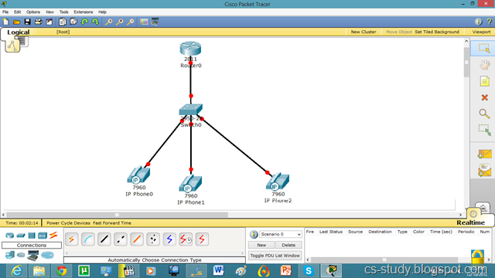

Internet telephony refers to communications services —voice, fax, SMS, and/or voice-messaging applications— that are transported via the Internet, rather than the public switched telephone network (PSTN). The steps involved in originating a VoIP telephone call are signaling and media channel setup, digitization of the analog voice signal, encoding, packetization, and transmission as Internet Protocol (IP) packets over a packet-switched network.

On the receiving side, similar steps (usually in the reverse order) such as reception of the IP packets, decoding of the packets and digital-to-analog conversion reproduce the original voice stream. Even though IP telephony and VoIP are used interchangeably, IP telephony refers to all use of IP protocols for voice communication by digital telephony systems, while VoIP is one technology used by IP telephony to transport phone calls.

Web browser 4

At least 64 MB RAM and 233 MB harddisk will be required for running the browser.

The Bowser should support the following internet protocols:

I.HTTP

II.EMAIL

III.FTP: File Transfer Protocol(FTP) is a network protocol used to exchange and manipulate files over a TCP computer network, such as the [Internet](http://en.wikipedia.org/wiki/Internet). An FTP client may connect to an FTP server to manipulate fileson that server.

IV.NNTP: TheNetwork News Transfer Protocol or NNTP is an Internet application protocol used primarily for reading and posting Usenet articles (akanetnews), as well as transferring news among news servers

V.TLS:Transport Layer Security(TLS) and its predecessor, Secure Sockets Layer (SSL), are [cryptographic](http://en.wikipedia.org/wiki/Cryptographic_protocol)protocols that provide security and data integrity for communications overTCP/IP networks such as the [Internet](http://en.wikipedia.org/wiki/Internet).

VI.EV:Extended Validation Certificates (EV) are aspecial type of X.509 certificate which requires more extensive investigation of the requesting entity by the Certificate Authority before being issued.

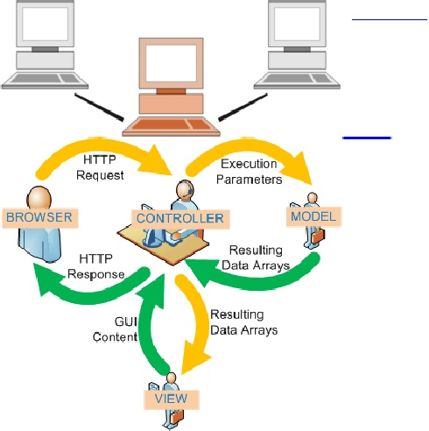

VII.GOPHER: Gopher is a distributed document searchand retrieval [network](http://en.wikipedia.org/wiki/Network_protocol)protocol designed for the [Internet](http://en.wikipedia.org/wiki/Internet). Its goal is to function as an improved form of Anonymous [FTP](http://en.wikipedia.org/wiki/File_Transfer_Protocol), enhanced with hyper linking features similar to those of the World Wide Web.

VIII.PROXY SERVER: In [computer networks](http://en.wikipedia.org/wiki/Computer_network), a proxy server is a server (a computer system or an application program) that acts as a go-between for requests from clients seeking resources from other servers.

A web browser should include these functions;

● Bookmark managing: Internet bookmarks are stored Web page locations (URLs) that can be retrieved. As afeature of all modernInternet web browsers, their primary purpose is to easily catalog and access web pages that a user has visited and chosen to save.

● Download managing: A download manager is a computer program dedicated to the task of downloading (and sometimes uploading) possibly unrelated stand-alone files from (and sometimes to) the Internet for storage.

● Password managing: It saves the password the user provides on various sites.

● Spell checker: In computing, a spell checker is an application program that flags words in a document that may not be spelled correctly. Spell checkers maybe stand-alone capable of operating on a block of text.

● Search Engine: Web search engine is a tool designed to search for information on the World Wide Web. The search results are usually presented in a list and are commonly called hits. The information may consist of web pages, images, information and other types of files.

● Privacy mode: Privacy mode is an informal term that refers to privacy features in some web browsers.

File Transfer

The necessary functions to perform file transfer are:

● be able to asynchronously copy a file from one server to another

● be able to recover from partial or failed transfers due to problems in the network or disk systems

● report to a user on the progress of a given request

● allow a user to signal the relative priorities of requests

● handle a multi-file file request as an atomic unit

● access files which reside on a set of data servers

● handle files on disk, which are accessible via a gridftp server

● handle files which are accessible a SRM server using gridftp as the transport protocol

● other protocols should be usable as the transport protocol

● require a user to be authenticated in order to use the service

● require a user to be authorized to use the service

● use the users proxy to do the transfer

* **The performance requirements including “the number of users that the network needs to support”, “the speed of the network” etc.**

**Performance Requirements**:

Metropolition area network(MAN) consists of a combination of many LANs which include many servers workstations and wireless users. Internet speed slowdowns will occur when a large number of people try to connect to the internet at the same time. The infrastructure must be constructed in such a way that it will not have a large number of users and will distribute the internet fairly to overcome it. It should also be aware that the hardware infrastructure must be created to keep the internet speed at the optimal level. There are several performance criterias to create the most suitable infrastructure.

**Connections Per Second;**

Connections per second (c/s) refers to the rate at which a device can establish state parameters for new connections. As previously noted, a stateful device must create and manage connection information on all unique IP streams that transit the device. Typically, the device must handle the first packet of a new connection differently than all subsequent packets so that the device can establish the state parameters for the new connection. The rate at which a device can establish state for new connections is related to factors such as processor (CPU) speed, memory speed, architecture, TCP/IP stack efficiency, etc. In terms of packet handling performance, the rate at which a device can handle packets when establishing state parameters is usually a small percentage of the rate at which the same device can forward packets in hardware once the state parameters are established.

**Maximum Concurrent Connections:**

Maximum concurrent connections (mcc) refers to the total number of sessions (connections) about which a device can maintain state simultaneously. This value is mainly related to the amount of memory that is dedicated to this task. However, even though memory is inexpensive, adding memory to support more concurrent connections makes little sense when the c/s rate is low.

**Transactions Per Second**

Transactions per second (t/s) refers to the number of complete actions of a particular type that can be performed per second. The t/s measurement refers to more than just the processing of a single packet or even the setup of a new connection; it refers to the completion of a full cycle of a specific action. As an example, in database design, t/s is a common metric, and it refers to the number of database transactions that are performed per second. In networking, certain devices use this metric to describe the application of certain complex process to the packets to comprise a full conversation.

As in the explained below, there are several requirements to accomplish suitable structure in different system.

**● Server:** Server machine should have a powerful CPU and high speed internet access so that it can handle multiple users at the same time.

**●**Another performance requirement is the storage space. Higher storage space means more user and bigger workspace per user so higher the storage, better the performance.

**Web browser**

* Static numerical requirements are:
* HTTP should be supported.
* HTML should be supported.
* Any number of users can be supported.
* Dynamic numerical requirements includes: the number of transactions and tasks and the amount of data to be processed within certain time periods for both normal and peak workload conditions depend upon the internet connection and speed of the user.

**Database**

In our system expected number of simultaneous user should be at least 140. System should be able to deal with 140 users at the same time. Also database of the system should handle at least three hundreds of users at any periods. It is expected to access into database as fast as possible with propriate frastructure.

When all these features are taken into consideration, it is left to choose the most appropriate topology. Determining the maximum number of users that can be in a network, reducing or avoiding conflicts, and also using the internet in the most efficient manner are the most important criteria in choosing a topology. There are four specified topologies such as mesh, bus, star and ring. It is also possible to use more than one topology at the same time in one system. Main topologies are explained below.

**Star Topology:**

In general, it is the most used topology. The advantage is that a separate line is drawn for each computer, so the problem in a terminal does not affect with other terminals. This topology has a dispenser point or box. It is connected to the end user by means of a single cable from this distributor point. Cables such as CAT-3,4,5 are used as the cabling system used for these networks. In addition, the hub (which allows sharing of bandwidth on a single line based on the number of users) device is used.

**Advantages of this topology:** Economic cabling, fast installation, easy expandability.

Expanding with a switch or bridge improves network performance. Connectivity gap does not affect the entire network. Connections to the Hub clearly show the status of the connections on the hub, making it easier to identify and troubleshoot.

**Bus Topology:**

Terminals are connected to each other on a single line. The cost is low. The disadvantage is that it affects other terminals when there is a problem in any terminal. In this type of network, coaxial cable is used. The computers are connected on the common cable. In this topology, cable connections are made from the computer to the computer with coaxial T-connectors not directly. In this type of topology, the packet goes up to the destination instead.

**Advantages of bus structure:** Uses reliable cable (coaxial cable), Provides simple network expansion, Does not require hub or similar central network equipment.

**Disadvantages of Bus Structure:** Disconnection of any node affects the entire network.

**Ring Topology:**

A packet sent from one computer to another is routed in a ring-shaped structure and transmitted to destination.

The requirements such as quality, availability, security and cost are explained above as in the performance criteria. The other requirement scalability is explained below.

In one respect scalability is simply specified as the increase in the system’s workload that the system should be able to process. The scalability required is often driven by the lifespan and the maturity of the system. For example, a new (and hence immature) system could suffer an unexpected growth in popularity and suffer from a significant increase in workload as it becomes popular with new users. More mature systems which represent improvements on older systems are likely to have more accurately defined workloads and thus be less likely to suffer in this respect

For give an example above scalability according to file transfer:

File transfer system provides scale to 500 MB/s continuous point-to-point transfer and 1GB/s peak point-to-point transfer. Also it is defined the simultaneous transfer of 100 files per point-to-point connection. This is able to store 1000 multi-file requests in the “pending transfer” queue per point-to-point connection with 100-1000 files per request job.

**Deﬁnitions of the System/Model**

For the system and its components to operate smoothly, we need to prepare the network structure for the required job. Because our network structure is a metropolitan area network, the structure used to communicate between campuses and on-campus computers must be properly constructed.

In the structure of the system, a metropolitan network was created using switches, rooters and other devices. Although many network topologies are used in the system, star topology is mostly used.

In the types of network topologies, there are common examples of area network types:

* + - LAN - Local Area Network
    - WLAN - Wireless Local Area Network
    - WAN - Wide Area Network
    - MAN - Metropolitan Area Network
    - SAN - Storage Area Network, System Area Network, Server Area Network, or sometimes Small Area Network
    - CAN - Campus Area Network, Controller Area Network, or sometimes Cluster Area Network
    - PAN - Personal Area Network
    - DAN - Desk Area Network

Also, network topologies are categorized into the following basic types:

* + - Bus
    - Ring
    - Star
    - Tree
    - Mesh

More complex networks can be built as hybrids of two or more of the above basic topologies.

The OSI model defines internetworking in terms of a vertical stack of seven layers. The upper layers of the OSI model represent software that implements network services like encryption and connection management. The lower layers of the OSI model implement more primitive, hardware-oriented functions like routing, addressing, and flow control. The figure below, shows the OSI Model Layers.

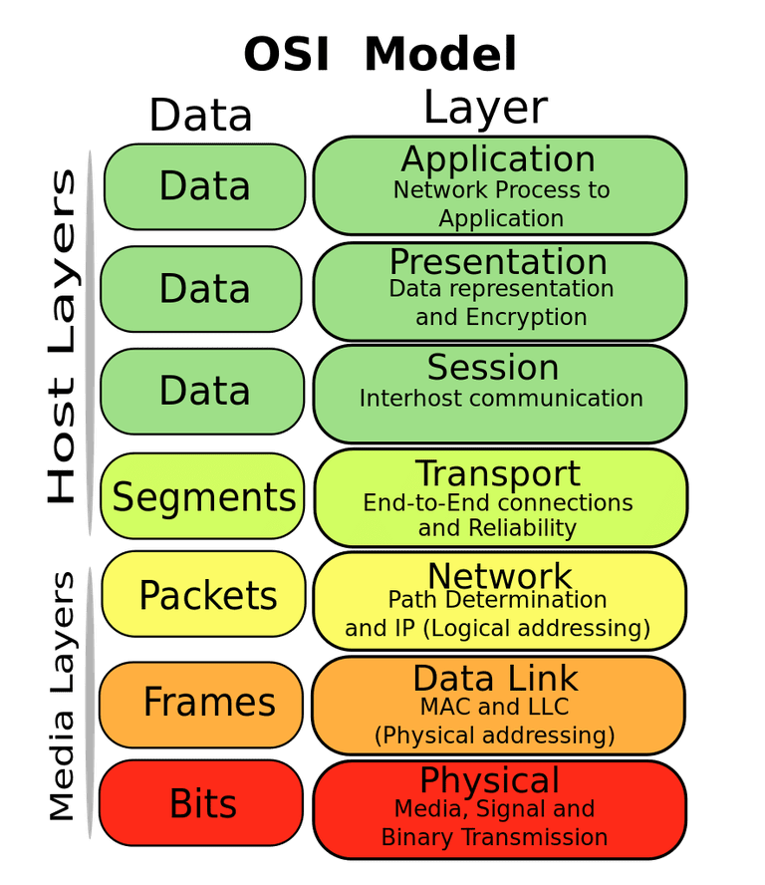

Figure 1 OSI MODEL

* Network configuration including addressing, routing, and equipment configuration

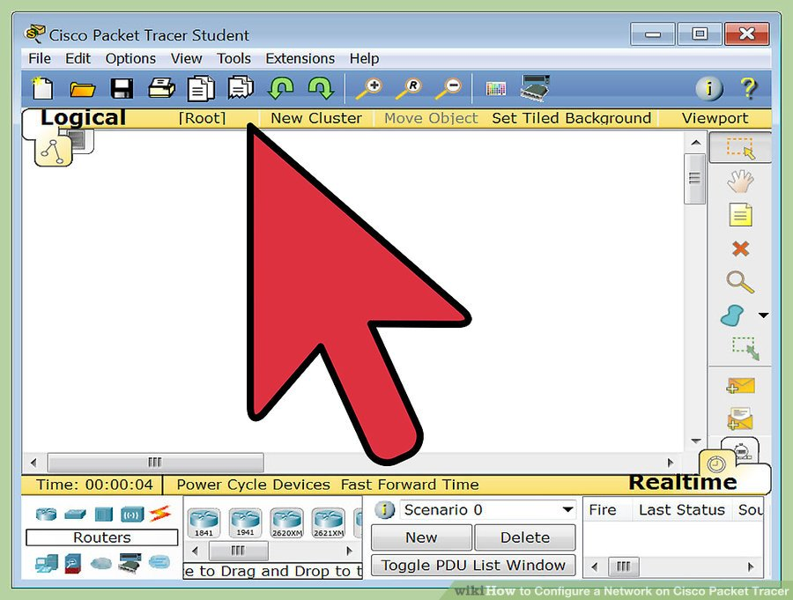

1. **Open your Network Topology.** Once you've opened your Network Topology on Cisco Packet Tracer, access your network and identify the components of your network, for example; Servers, Routers, End Devices, etc.

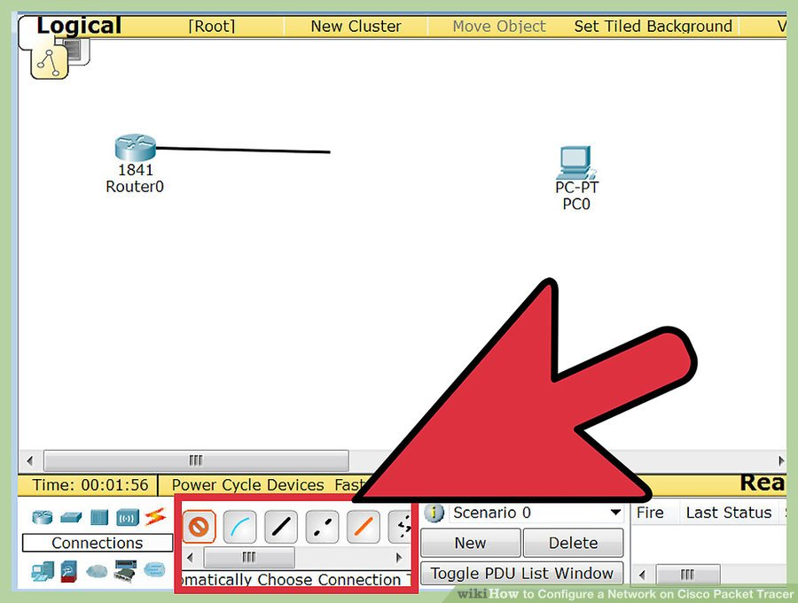

1. **Complete the cabling.** Access the cables section and connect completely and correctly the cables between the network in order to ensure connectivity between the devices in the network using the connections table given.

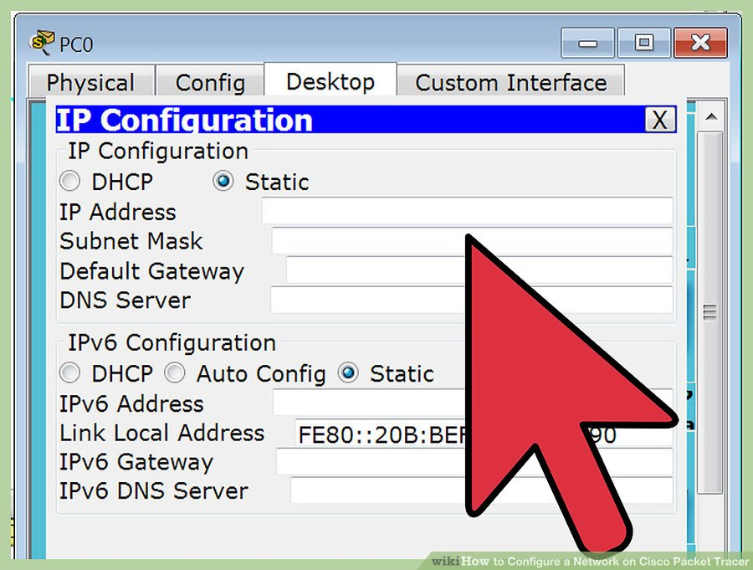

1. **Configure the IP addresses on the end devices.** Using the address table still, correctly and completely configure the IP addresses on all end devices. This can be done by accessing the desktop platform on each device and locating the IP configuration section. The reason for doing this is to enable the devices be on the right network.

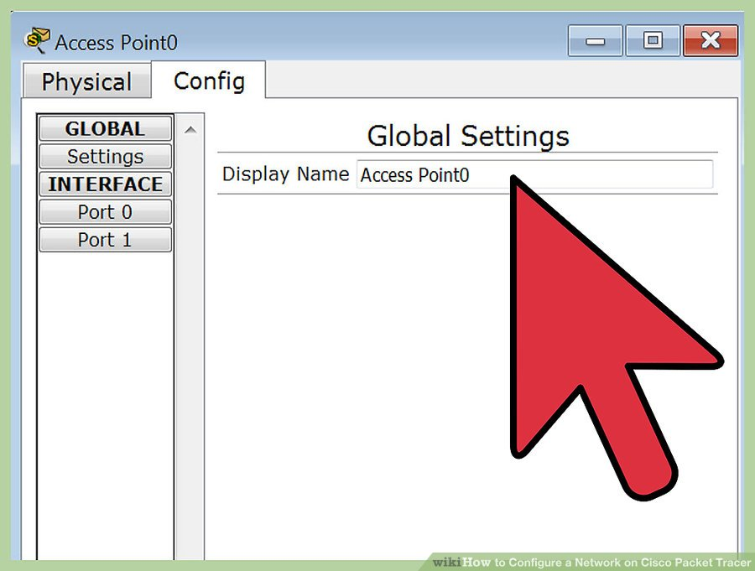

1. **Configure the IP addresses on your routers and switches.** After configuring the right IP addresses on the end devices, you will have to do the same on the routers and switches also, using the address table. But this time in a different way because there's no desktop platform on the routers and switches. You will have to access the configuration panel on both devices and this can be done in two ways:

* Click on the device and open the Command Line Interface (CLI) and then type in the right commands to configure the right addresses for the router using the addressing table.
* Use a console cable from an end device and connect it to the device you wish to configure and access the terminal platform on the end device and it will take you to the device's Command Line Interface and then you type in the commands in other to configure the right addresses.

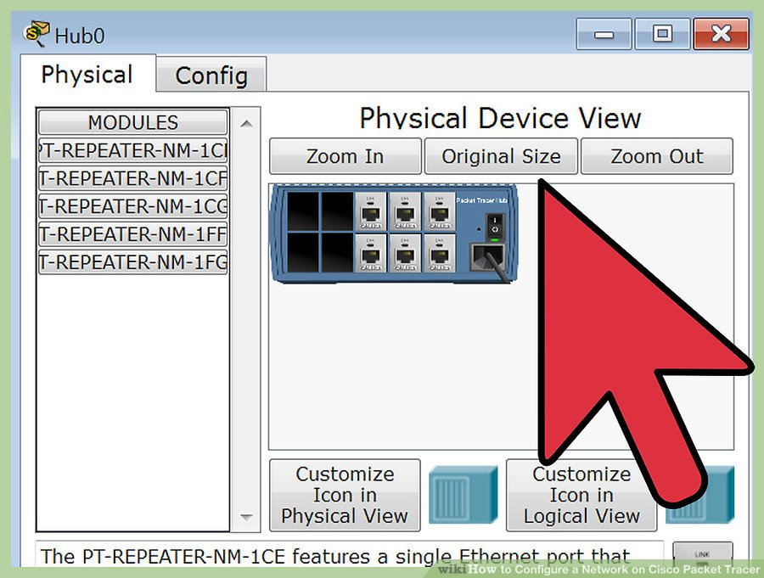

1. **Configure your default gateway.** After configuring the IP addresses, you will need to configure the default gateway also. The reason for this is so the end devices would know what network they are operating on. You can find the default gateway either in the addressing table (if given) or in the network topology.

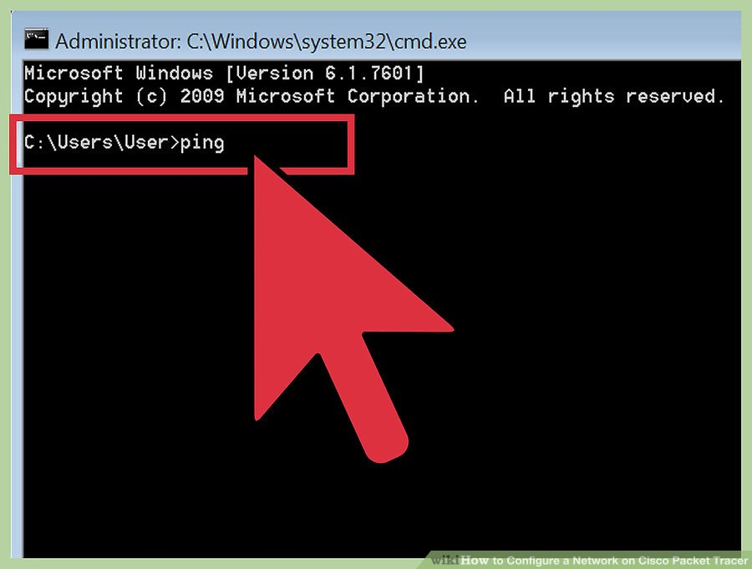

1. **Test connectivity.** After configuring the addresses, you will have to test connectivity by opening a command prompt window on the end devices and try pinging the address which the network operates on. If it gives you a reply, it means your network was configured correctly. [34]

* Data types, data sources

In computer network, there are two types of datas : digital and analog.

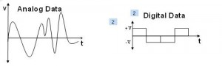

Usually computers can understand only digital data.

On the other hand, a data source, in the context of computer science and computer applications, is the location where data that is being used come from. Applications such as relational database management systems and even websites use databases as primary data sources.

• Network applications and services

In computer networking, a network service is an application running at the network application layer and above, that provides data storage, manipulation, presentation, communication or other capability which is often implemented using a client-server or peer-to-peer architecture based on application layer network protocols.

Network applications and services that will be modeled/deployed

* Email
* File sharing
* Instant messaging
* Printing
* File server
* Voice over ip
* Video on demand
* Video telephony
* World wide web
* Wireless sensor network

Device types

* Host
* Switch
* Hub
* Repeater
* Bridge
* Managed Device
* Destination and Number of Users

The teams destination is to make the best estimation and the proposal for the university network using the numbers of shown in below:

* + - * 260 workstation users
      * 15 wireless users
      * 4 database servers,
      * 2 Web servers
      * 1 file storage server,1 mail server and 1 domain name server (DNS)
* Performance and functionality of the infrastructure

Network infrastructure is the hardware and software resources of an entire network that enable network connectivity, communication, operations and management of an enterprise network. It provides the communication path and services between users, processes, applications, services and external networks/the internet.[33]

* Traffic Pattern

Network traffic or data traffic is the amount of data moving across a network at a given point of time. Network data in computer networks is mostly encapsulated in network packets, which provide the load in the network. Network traffic is the main component for network traffic measurement, network traffic control and simulation. The proper organization of network traffic helps in ensuring the quality of service in a given network. [32]

1. **Simulation Elements**

The simulation elements of the team project regarding following categories are shown below:

• System entities (e.g. computer nodes, server, the queue, packets, ﬂows of packets etc.)

1. Computer Nodes:

In a communications network, a network node is a connection point that can receive, create, store or send data along distributed network routes. Each network node -- whether it's an endpoint for data transmissions or a redistribution point -- has either a programmed or engineered capability to recognize, process and forward transmissions to other network nodes.[1]

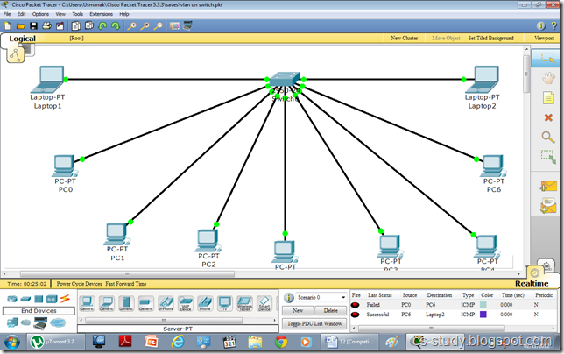

1. Server:

A server is a computer program that provides a service to another computer programs (and its user). In a data center, the physical computer that a server program runs in is also frequently referred to as a server. That machine may be a dedicated server or it may be used for other purposes as well. Servers are often categorized in terms of their purpose. A Web server, for example, is a computer program that serves requested HTML pages or files. The program that is requesting web content is called a client. For example, a Web browser is a client that requests HTML files from Web servers. [2]

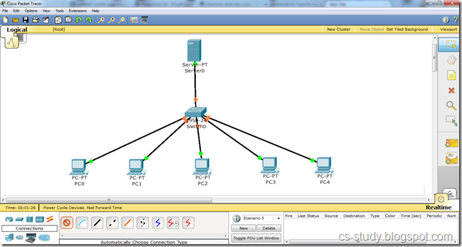

1. The queue:

The term 'network of queues' describes a situation where the input from one queue is the output from one or more others. A simple example of network queueing is the central server network. This consists of a CPU (Central Processing Unit), storage units it can access and input devices to access it. The task the CPU performs are queued on different criteria. Also, the storage units could have their own individual queues. Queues tend to be ordered in a number of ways. [3]

1. Packets:

A packet is the unit of data that is routed between an origin and a destination on the Internet or any other packet-switched network. [4] 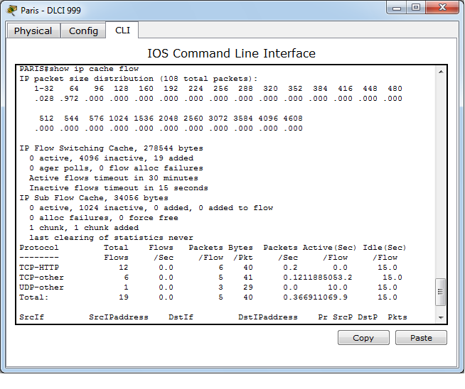

A packet consists of control information and user data,[5] which is also known as the payload. The Figure 1. Below, is a example of a e-mail packet format.[6]

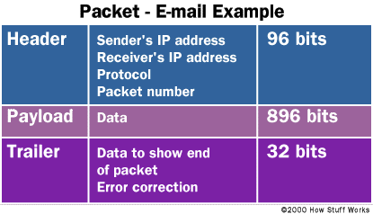

Figure 2. Example E-Mail Packet

1. Flows of Packets:

In packet switching networks, traffic flow, packet flow or network flow is a sequence of packets from a source computer to a destination, which may be another host, a multicast group, or a broadcast domain. The Figure 2. Below, is a superficial representation of the packet flow [7].

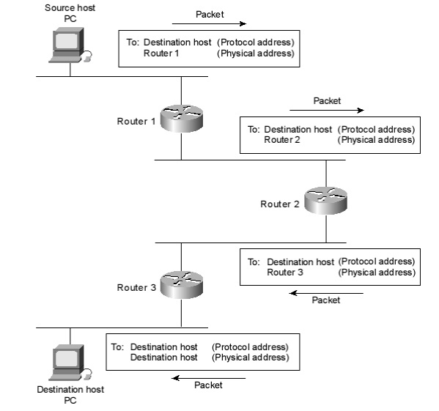

Figure 3 . Packet Flow

1. Routers / Switches:

Switches create a network. Routers connect networks. The two pieces of equipment look similar and perform some similar functions, but each has its own distinct function to perform on a network. [8]

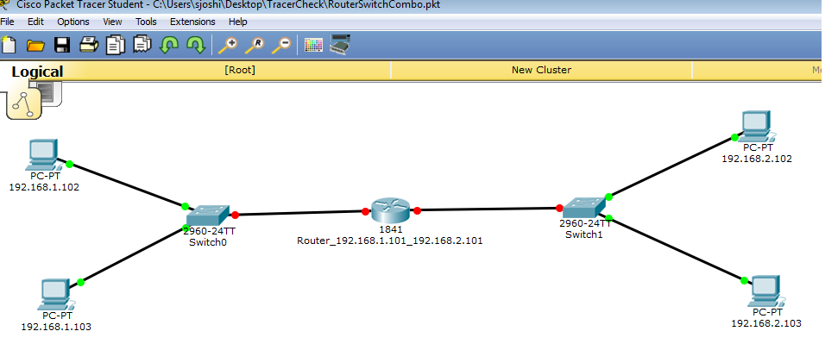

• System state variables (e.g. status of the channel which is either idle or busy etc.),

In Packet Tracer, there is a command line interface to checking port status and connectivity. User can view summary or detailed information on the switch ports using the “show interfaces status” command. To see summary information on all ports on the switch, entering the “show interfaces status” command with no arguments. Specify a particular module number to see information on the ports on that module only. Entering both the module number and the port number to see detailed information about the specified port.

This example shows how to display the status of all interfaces on a Catalyst 4500 series switch, including transceivers. Output of this command displays “Unapproved GBIC” for non-Cisco transceivers: [9]

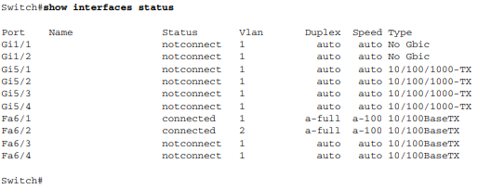

Also, user can display the currently active user sessions on the switch using the show users command. The command output lists all active console port and Telnet sessions on the switch. To display the active user sessions on the switch, perform this task in privileged EXEC mode, as shown below in Figure 3. [9]

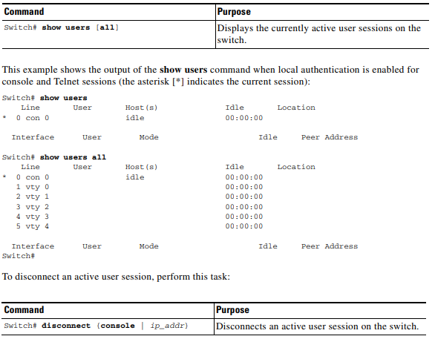

• Input variables (e.g. arrival rate, service rate etc.),

Configuration file is a file that contains configuration information for a particular program. When the program is executed, it consults the configuration file to see what parameters are in effect.[10] Therefore, when we make any changes in Switch or Router settings (like changing the host name, putting passwords , the arrival rate, service rate, …etc), and save those changes by the command:

Copy running-config startup-config

The device(switch or router) will CREATE a file named (startup-config) and saves it in NVRAM . [11]

• Resources (e.g. bandwidth, the number of servers, transmission time etc.)

1. Clock Rate vs Bandwidth:

The user can change the clock rate, by the Configuration File as mentioned in Input Variables section. Clock rate is to be used in DCE in serial link to configure the clock speed for the link. However, bandwith is the value that will be used in computation of metrics depending on bandwitch, for example in EIGRP.

When user set the clock rate for a serial interface, user is setting the speed of the interface, in other words, the bandwidth (bandwidth meaning rate of data transfer).

1. Examples of Clock Rate and Bandwidth usage

If user have only subscribed for a 64k line, then the clock rate would have been set on the DCE side of the cable using the command ‘clock rate 64000’ under the interface.

router# conf t

router(config)# interface serial 1/0

router(config-if)# clock rate 64000 (represented in BITS per second)

The bandwidth command however does not adjust the speed of the line at all, however it should be configured on ALL DTE and DCE interfaces because it is used by;

1) Routing protocols – to calculate the cost of a path

2) QOS (Quality of Service) – to identify how much bandwidth is available to prioritize,

If no bandwidth command has been configured on the interface, Routing protocols and QOS will assume the line is running at the maximum speed supported by the interface which can result in incorrect routing and incorrect prioritization of packets.

The bandwidth command is issued under the interface, as is represented in Kilobits per second

router# conf t

router(config)# interface serial 1/0

router(config-if)# bandwidth 64 (represented in kilobits per second)

1. The number of Servers:

The user can able to create these servers:

* HTTP /Web Server
* DNS Server
* DHCP Server
* Mail Server
* FTP server

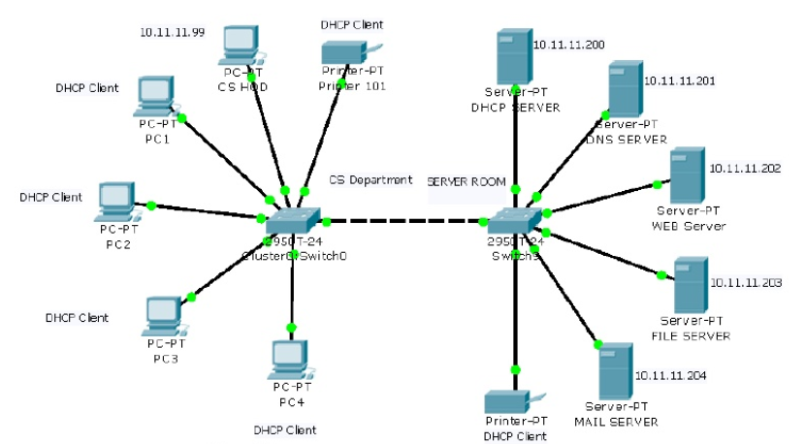

As the reference shows which is Packet Tracer Server and client documentation[12], the user able to change the server type in the configuration window.

1. Transmission Time:

In telecommunication networks, the transmission time, is the amount of time from the beginning until the end of a message transmission. In the case of a digital message, it is the time from the first bit until the last bit of a message has left the transmitting node.[13]

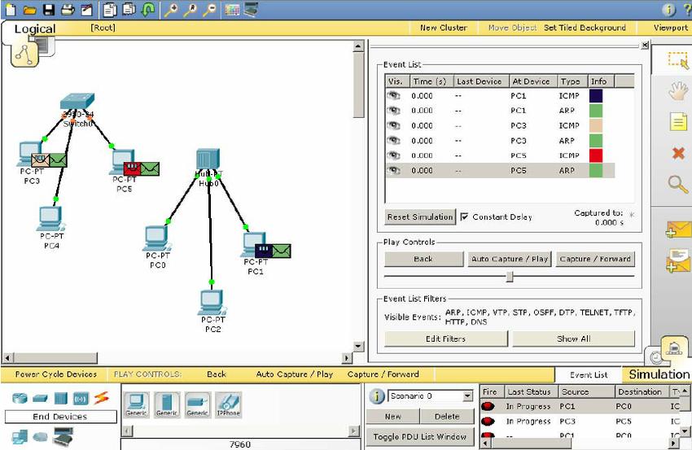

Figure 6 is a screen shot of two small networks and the representation of the time- based events that are occurring on the devices. The right side of Figure 6 includes an event list that is configurable by the user. As the various devices send and receive messages the network traffic can be observed and the history of the network can be stopped, reversed and explored.[14]

• Activities and events (e.g. delay, queuing, packet arrival etc.),

1. Delay:

Network delay is an important design and performance characteristic of a computer network or telecommunications network. The delay of a network specifies how long it takes for a bit of data to travel across the network from one node or endpoint to another. It is typically measured in multiples or fractions of seconds.[15] In packet tracer, the user can able to see all the delays in the command window, as shown in referenced video [16].

1. Queuing:

In telecommunication and computer engineering, the queuing delay or queueing delay is the time a job waits in a queue until it can be executed. It is a key component of network delay. In a switched network, queuing delay is the time between the completion of signaling by the call originator and the arrival of a ringing signal at the call receiver. Queues may be caused by delays at the originating switch, intermediate switches, or the call receiver servicing switch. [17]

1. Packet Arrival:

As shown below in the figure 7, the packet has been delivered to the PC1 to PC2, the time that passed through the transmission showed in the right side of the figure 7.

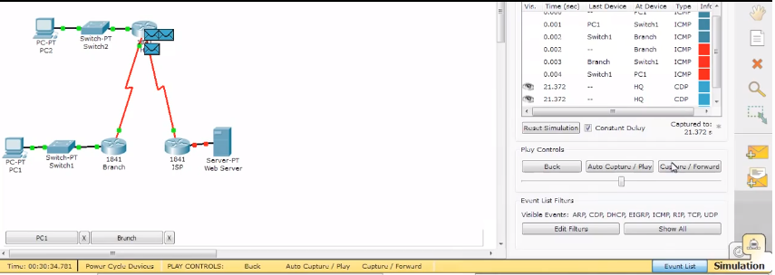

Figure 4. The Time in Packet Tracer Simulation[18]

• Performance measures (e.g. mean waiting time, maximum queue length, mean packet transmission latency etc. )

1. Mean Waiting Time

Mean waiting time is important measures of Quality of Service (QoS) in simultaneous users accessing a web server. [19]

1. Maximum Queue Length

In the reference [35] the average and the limit queue size is explained and the figure shows the average queue size.

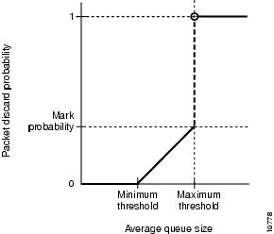

1. Mean Packet Transmission Latency

Network latency is an expression of how much time it takes for a packet of data to get from one designated point to another. In some environments (for example, AT&T), latency is measured by sending a packet that is returned to the sender; the round-trip time is considered the latency. Ideally latency is as close to zero as possible.

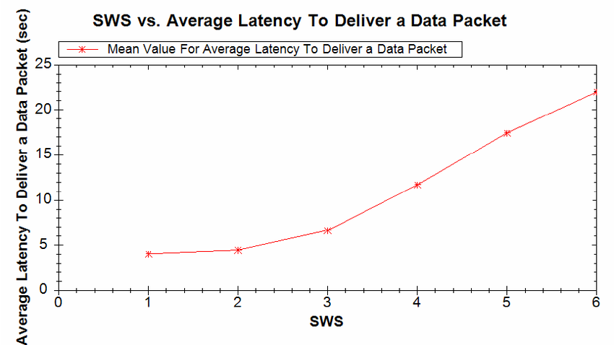

1. References
2. References
3. Computer Node Definition, Margaret Rouse, August 2016 https://searchnetworking.techtarget.com/definition/node
4. Server Definition, Margaret Rouse, January 2018 https://whatis.techtarget.com/definition/server
5. The Term “ Network of Queues”, Robert Kay, June 1999 https://www.andrewferrier.com/oldpages/queueing\_theory/Rob/index.html
6. Packet Definition, Margaret Rouse, April 2007

https://searchnetworking.techtarget.com/definition/packet

1. Stallings, William (2001). "Glossary". Business Data Communication (physical book) (4 ed.). Upper Saddle River, New Jersey, USA: Prentice-Hall, Inc. p. 632. ISBN 0-13-088263-1. Packet: A group of bits that includes data plus control information. Generally refers to a network layer (OSI layer 3) protocol data unit.
2. Figure 1. Example of E-mail Packet - "What is a packet?" 1 December 2000. https://computer.howstuffworks.com/question5251.htm
3. Figure 2. Packet Flow, May 2015 https://supportforums.cisco.com/t5/wan-routing-and-switching/packet-flow/td-p/2708169 Adsasd
4. Routers and Switches Definition, Cisco https://www.cisco.com/c/en/us/solutions/small-business/resource-center/connect-employees-offices/network-switch-what.html
5. System Status Variable in Packet Tracer <https://www.cisco.com/c/en/us/td/docs/switches/lan/catalyst4500/12-2/31sg/configuration/guide/conf/connect.pdf>

Configuration file Definition <https://www.webopedia.com/TERM/C/configuration_file.html>

Configuration File Content, Ehab , September 2016 <https://learningnetwork.cisco.com/docs/DOC-31329>

Packet Tracer Server and Client https://tr.scribd.com/doc/98222432/Cisco-Packet-Tracer-Server-and-Client-Configuration-Help-File

Transmission Time Definition https://en.wikipedia.org/wiki/Transmission\_time

https://www.researchgate.net/figure/Packet-Tracer-interface-for-viewing-time-based-events-with-different-IP\_fig1\_225119105

Delay Definition

https://en.wikipedia.org/wiki/Network\_delay

Packet Tracer Simulation CCNA: EIGRP bandwidth, delay and variance <https://www.youtube.com/watch?v=ZMSYx7HRlXs>

Queuing delay definition, <https://en.wikipedia.org/wiki/Queuing_delay>

Using Packet Tracer Simulation Mode to Troubleshoot Routes <https://www.youtube.com/watch?v=pvMSkIH4ncU>

1. Modeling and Performance Evaluation of Mean Waiting Time

for Multiple Web Access in the Narrowband Network , Y. –J.Lee, May 2014

[20]Channel Definition, http://www.wiki-zero.com/index.php?q=aHR0cHM6Ly9lbi53aWtpcGVkaWEub3JnL3dpa2kvQ29tbXVuaWNhdGlvbl9jaGFubmVs

[21]Protocol Definition, https://searchnetworking.techtarget.com/definition/protocol

[22]System Definition, https://searchwindowsserver.techtarget.com/definition/system

[23]Architecture Definition, http://www.wiki-zero.com/index.php?q=aHR0cHM6Ly9lbi53aWtpcGVkaWEub3JnL3dpa2kvTmV0d29ya19hcmNoaXRlY3R1cmU

[24] Router Definition, https://searchnetworking.techtarget.com/definition/router

[25]Switch Definition, http://www.wiki-zero.com/index.php?q=aHR0cHM6Ly9lbi53aWtpcGVkaWEub3JnL3dpa2kvTmV0d29ya19zd2l0Y2g

[26] Network Definition, https://www.techopedia.com/definition/25597/computer-network

[27] Hub Defition, https://www.computerhope.com/jargon/h/hub.htm

[28]Host Definition, http://www.wiki-zero.com/index.php?q=aHR0cHM6Ly9lbi53aWtpcGVkaWEub3JnL3dpa2kvSG9zdF8obmV0d29yayk

[29] Bandwidth Definition, https://searchnetworking.techtarget.com/definition/bandwidth

[30] Soham Ghosh, Network Design Proposal for University https://www.youtube.com/watch?v=J8iaRyEO7iw&t=182s

[31] Mohammed Nadir Bin Ali1, Mohamed Emran Hossain, Md. Masud Parvez, Daffodil International University, Design and Implementation of a Secure Campus Network, Volume 5, Issue 7, July 2015

[32] Network Traffic Definition , https://www.techopedia.com/definition/29917/network-traffic

[33] Network Infrastructure Definition , https://www.techopedia.com/definition/16955/network-infrastructure

[34] Network Configuration, https://www.wikihow.com/Configure-a-Network-on-Cisco-Packet-Tracer

[35]Discrete Event simulation http://www.simulace.info/index.php/Discrete\_event\_simulation